Hamoye Data story telling stage c project.

WHICH STATES IN NIGERIA WERE HIT THE HIGGHEST BY THE COVID-19 PANDEMIC?

The covid-19 pandemic is an infectious disease that slowly but steadily ravaged the world since the discovery of the first case in Wuhan, China.

Nigeria was not left behind even with the almost 15000 km distance between China and Nigeria. Some people predicted that the impact of the pandemic on Africa as a whole was going to be disastrous, leaving very few survivors. Looking back, we can tell those predictions weren’t totally accurate as we can still account for the lives lost and the total number of infected people.

This report is however not going to debate any predictions given, instead it is going to focus on how several states in Nigeria were affected by the covid-19 pandemic so any average Nigerian can understand how well their state responded in context with the other states in Nigeria.

There are 36 states in total in Nigeria, with Federal Capital Territory, FCT being the capital. Lagos is also considered one of the most developed and busiest.

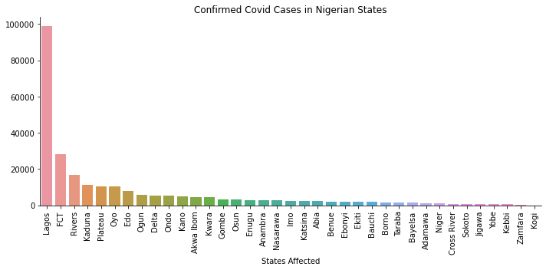

It can be seen from the figure that Lagos state has the highest number of people confirmed to have covid and the number is much greater that that of any other state. Abuja follows right after Lagos with about 30,000 confirmed cases and Kogi has the least number of people confirmed to have covid with barely any covid cases at all.

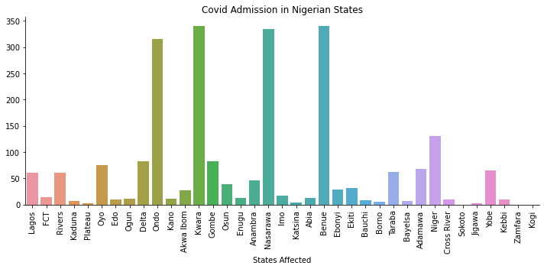

This graph shows the current number of people admitted currently with covid. It is clear that currently Ondo, Nasara, Kwara and Benue have the largest number of people admitted so more medical personnels and supplies should be channelled there.

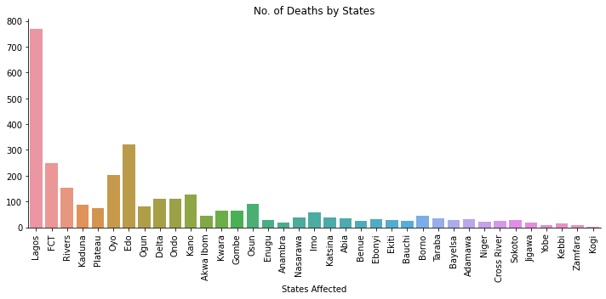

As expected, Lagos has the highest number of deaths at about 760 people. Oyo and Edo have an unexpected high number of death when compared to the confirmed cases trend.

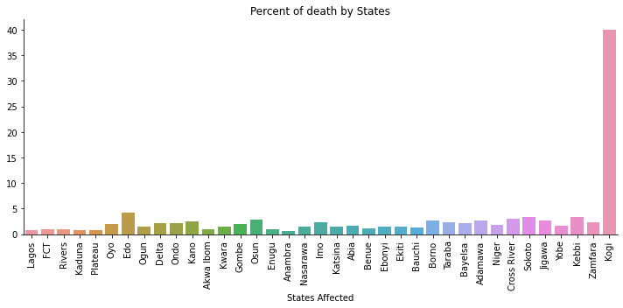

From the graph of percentage of people who died compared with those confirmed to have it, Kogi tops the chart with Edo, Kebbi and Zamfara with a little significant percentage. All of the other states apart from Kebbi have a quite insignificant number of deaths, i.e. lower than 5 percent.

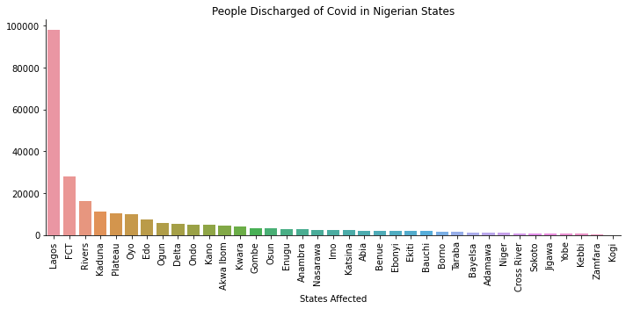

The number of people discharged follows the same trends of the number of people admitted.

In conclusion, Lagos had the highest number of cases with a significantly good recovery rate and only a small percent of deaths.

